# Anuj Jain



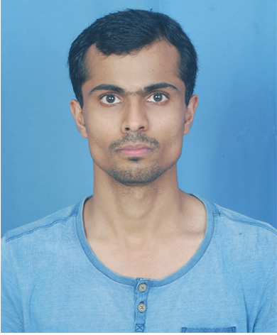Formal Picture (White Background)

**Quality Assurance Lead**

## Experience summary

Anuj Jain has 6 years and 11 months of experience in the software industry. He has experience in software automation testing. He offers exposure in working on Selenium, Test Complete, TestStack.White and Ready API tools along with vast experience in functional and regression testing of web and Windows-based applications.

## Trainings and certifications

* 70-461 Querying Microsoft SQL Server 2012

## Skill set

|  |  |
| --- | --- |
| **Programming and scripting languages** | Python, C# |
| **AI/ML Libraries.** | OpenCV, Statistics, Numpy, Pandas, Matplotlib,Sklearn,Matplotlib and Anaconda |
| **Frameworks, Tools and Libraries** | Hybrid and Page Object Model Framework. Selenium, Test Complete, TestStack.White, GIT, BitBucket, JIRA, Confluence and Zephyr. |
| **IDE** | Pycharm, Jupyterlab, Jupyter Notebook and Visual Studio. |
| **Servers and Platforms** | Window Server 2012 |
| **Databases** | MS-SQL Server 2008/12/14 |
| **Operation System** | Window 7/8.1/10 |

## Education

* Master of Computer Application, Birla Institute Applied Science, Bhimtal India

## Honors and awards

* 2-Times Morpheus award for implement Innovative ideas.

## Recent projects

### Retail Application

|  |  |
| --- | --- |
| **Client** | Client is a leader in Retail Management software that is recognized worldwide for its rich functionality, multi-national capabilities, and unparalleled flexibility and having products iVend Retail solutions for point of sale, loyalty, eCommerce, digital passes, analytics, and mobility will increase revenue, improve customer retention, and bring in new business, all while lowering your operating costs. |
| **Project overview** | iVend Retail is desktop base application. iVend Retail omnichannel retail management suite enhances the customers’ shopping experience with a seamlessly-integrated retail application s iVend Retail’s multi-store, multi-user, eCommerce and loyalty-ready abilities are available on terminal and mobile devices for taking customer engagement to a whole new level. |
| **Technologies** | Automation Testing- TestComplete using Python, DevAzure |
| **Responsibilities** | * Prepared test scripts for Desktop application using TestComplete with python and DevAzure. * Code Review * Analysis Test Logs. |

### Syncplicity

|  |  |
| --- | --- |
| **Client** | Axway is a publicly-held information technology company that provides software tools for Managed File Transfer and B2B integration heritage. |
| **Project overview** | Syncplicity is a file share and synchronization service developed by Syncplicity (Axway) Inc. The service lets users store and synchronize files between computers. |
| **Technologies** | C#, TestStack.White and Selenium using Python |
| **Responsibilities** | * Implement automation test scripts and ensure that they run reliably on deferent platform. * Coordinate with product development engineers to design all test plans and analyze all functional and non-functional requirements automation. |

### Investment Manager Services (IMS)

|  |  |
| --- | --- |
| **Client** | SEI is a global provider of investment processing, investment management, and investment operations solutions. |
| **Project overview** | IMS helps to deliver information in a manner that is concise and meaningful, with a single point of access to consolidated reports across all accounts funds and products. |
| **Technologies** | Test Complete with Python. |
| **Responsibilities** | Develop Automation Framework using Test Complete Python.  Perform Failure analysis (Debugging the failed scripts and finding whether it is an issue (Bug in application). |

### CPM (Canteen Project Management)

|  |  |
| --- | --- |
| **Client** | The Canteen Stores Department, (CSD), is a solely owned Government of India Enterprise under the Ministry of Defence. |
| **Project overview** | This portal is essentially used to manage the smart card requests. The process of issuance of a smart card involves card request, printing, personalization, invoicing and then dispatch to the respective canteen |
| **Technologies** | Selenium and TestComplete using Python |
| **Responsibilities** | Designing and writing test automation scripts.  Execution automation in release time and perform failure analysis. |

### Boston Housing Price Prediction(Machine Learning)

|  |  |
| --- | --- |
| **Client** | NA(Self Learning) |
| **Project overview** | In this project, I use the Boston Housing dataset to train an optimal decision tree algorithm to predict the best selling price of a home in Boston based on certain features of the homes and statistical analysis. |
| **Technologies** | Python, NumPy,Pandas,Matplotlib and scikit-learn |